Social share buttons

### A MINI PROJECT REPORT

#### Submitted by: Bhuvesh Mittal (2210991450)

#### Group/Team No: G5/T5

**Bhupesh Relan (2210991447)**

**Bhuvan Kumar (2210991448)**

**Bhuvesh Kumar (2210991449)**

**Bhuvesh Mittal (2210991450)**

#### in partial fulfillment for the award of the degree of

## BACHELEOR OF ENGINEERING

***in***

COMPUTER SCIENCE & ENGINEERING



**CHITKARA UNIVERSITY**

**CHANDIGARH-PATIALA NATIONAL HIGHWAY**

**RAJPURA (PATIALA) PUNJAB-140401 (INDIA)**

##### MAY 2023

###### TABLE OF CONTENTS

|  |  |  |
| --- | --- | --- |
| Sr.no | Section | Page no |
| 1. | INTRODUCTION | 3 |
| 2. | **PROBLEM STATEMENT** | 4 |
| 3. | TECHNICAL DETAILS | 5 |
| 4. | PROJECT ADVANTAGES AND KEY FEATURES | 8 |
| 5. | RESULTS | 9 |
| 6. | CONCLUSION | 26 |
| 7. | Future Scope | 27 |
| 8. | REFERENCES /LINKS USED | 28 |

**INTRODUCTION**

Here are some key points to introduce social share buttons:

Social share buttons are a set of clickable icons or buttons placed on web pages, blog posts, or other digital content that allow users to easily share that content on social media platforms.

Social sharing buttons are an important feature for website owners and content creators who want to increase their online presence and reach a wider audience. By making it easy for visitors to share content, they can help to increase traffic to a website, generate more social media followers, and ultimately, grow a brand or business online.

When a user clicks on one of these buttons, they are directed to a share page on the social media platform of their choice, where they can add their own message to accompany the shared content. This allows for easy and convenient sharing of content across multiple social media platforms, helping to increase the reach and visibility of the content.

**PROBLEM STATEMENT**

In this project, we will take up the challenge of writing JavaScript code that will allow us to add social share buttons to static sites. While we can do this by incorporating HTML elements or images in the site’s template, using JavaScript allows us to add the share buttons dynamically.

**TECHNICAL DETAILS**

**USE OF HTML**

HTML can be used to create the content of a social share buttons, as well as provide the structure and layout of the web pages. Here are some key points why we use HTML in social share buttons:

1.Content: HTML can be used to create the content of the buttons, such as text, images, or links.

2.Structure: HTML can be used to define the structure and layout of the pages, such as its size, position, and background colour.

3.Customization: HTML can be customized with CSS to match the look and feel of the application, including the font, colour, and layout of the button & pages.

4.Responsiveness: HTML can be used to create responsive buttons that adapt different screen sizes and devices, ensuring that the button is legible and visually appealing on all devices.

5.Accessibility: HTML can be used to ensure that the website is accessible to all users, including with disabilities. For e.g., HTML can be used to provide alternative text for images or to use semantic HTML to make the button more understandable for screen readers.

**USE OF CSS**

CSS can be used to style the appearance and behavior of social share buttons in web applications. Here are some ways CSS can be used in:

1. Positioning: CSS can be used to position share buttons on the screen, such as at the top or bottom of the screen. This can be achieved using the CSS position property and the top, bottom, left, or right properties.
2. Styling: CSS can be used to style the appearance of web pages, such as the background colour, font, and size of the text, and the border and box-shadow properties of the notification container.
3. Animation: CSS animations can be used to add visual effects to buttons, such as fading in and out or sliding up and down. This can be achieved using the CSS animation property and the key frames rule.
4. Responsive design: CSS can be used to make buttons responsive, so they adapt to different screen sizes and devices. This can be achieved using media queries to define different styles for different screen sizes.
5. Customization: CSS can be used to customize buttons to match the look and feel of the application, using the application's colour scheme and branding.

**Use of JavaScript**

JavaScript plays a crucial role in implementing share buttons and provides several key uses. Here are some common uses of JavaScript in share button functionality:

Displaying and Hiding: JavaScript is responsible for showing the share buttons. It can add or remove classes to control the visibility, position, and animation effects of the toast share buttons.

Dynamic Content: JavaScript enables dynamic content in web pages. It allows for personalized or real-time information to be shared by the buttons.

Interaction and Event Handling: JavaScript allows for interaction with the buttons. For example, we can include links in the buttons, and JavaScript can handle click events on those elements. This enables actions like redirecting to another page, or performing specific operations based on user input.

Customization and Styling: JavaScript can be used to apply custom styles and animations to the buttons. By dynamically updating the CSS properties or classes, JavaScript allows for flexible customization to match the overall design of the website or application.

Overall, JavaScript empowers developers to create interactive, dynamic, and visually appealing buttons that share important information to users in a non-intrusive manner. It enables customization, event handling, and seamless integration with other parts of the web application, enhancing the user experience.

**PROJECT ADVANTAGES AND KEY FEATURES**

Some of the key features of social share buttons include:

1. Social share buttons are designed to work with popular social media platforms
2. Social share buttons are typically very easy to use.
3. Social share buttons can be customized to fit the design and branding of a website or blog
4. They are designed to be responsive and work well on smaller screens.
5. Social share buttons help promote social engagement and increase the reach of content.

**RESULTS**

1.Social sharing buttons are a common feature found on many websites and online platforms. They typically consist of small icons or buttons that allow users to easily share content various social media platforms, such as Facebook, Twitter, and LinkedIn.

2.In terms of their impact on a project, social sharing buttons can have several benefits. For one, they can help to increase the visibility of a project by allowing users to share it with their own social networks. This can help to attract more visitors to the project's website or platform, which can ultimately lead to increased engagement and success.

3.Additionally, social sharing buttons can help to foster a sense of community around a project. By making it easy for users to share content with their friends and followers, social sharing buttons can encourage people to engage with the project and become more invested in its success.

4.Overall, social sharing buttons can be a valuable tool for any project that wants to increase its reach and engagement. By making it easy for users to share content, these buttons can help to amplify the project's message and build a strong community of supporters.

**Home Page: -**

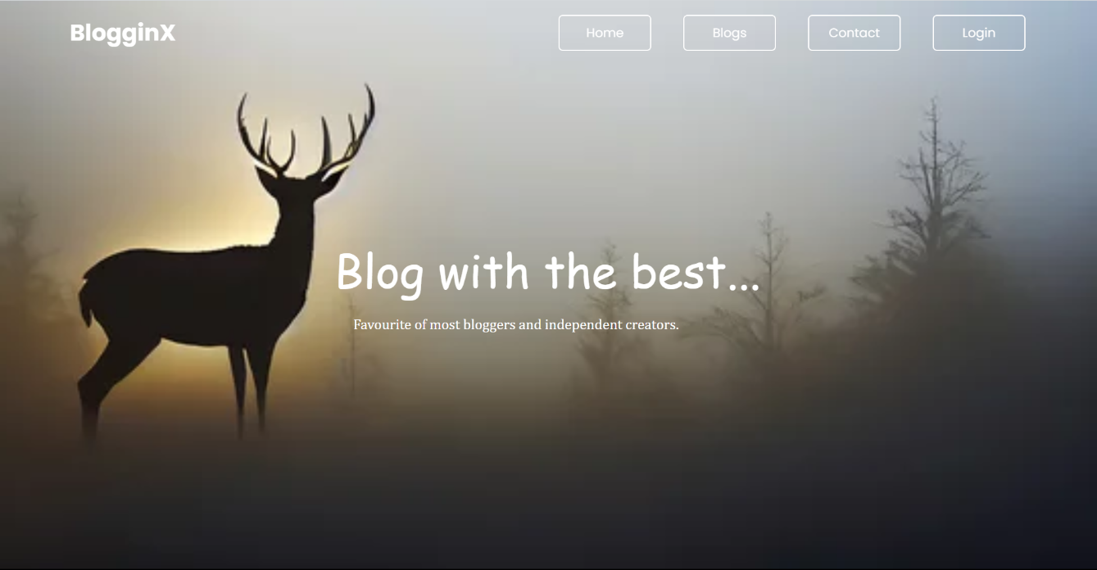

**Blog page: -**

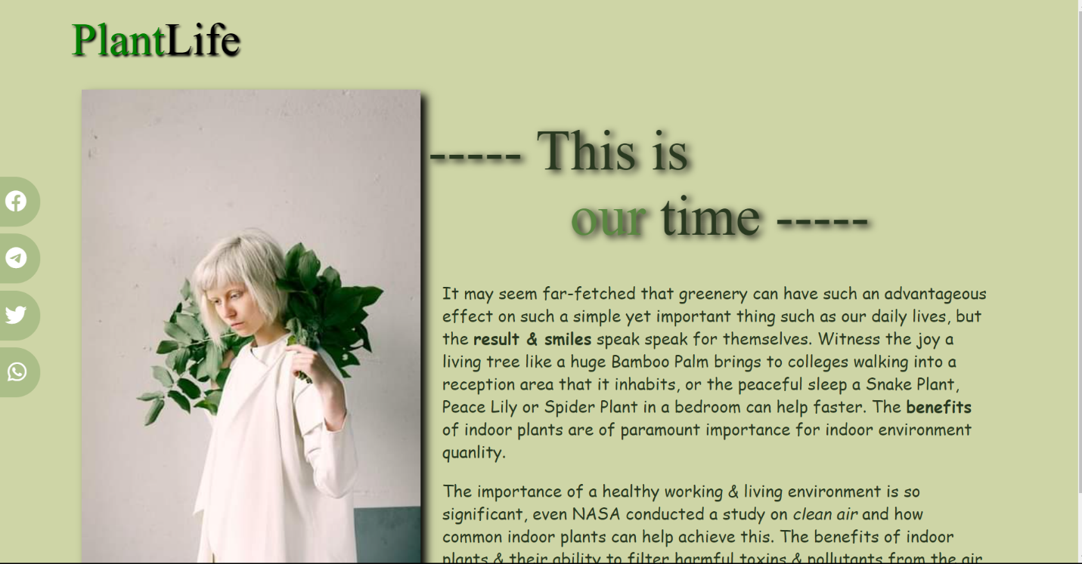

**Contact page: -**

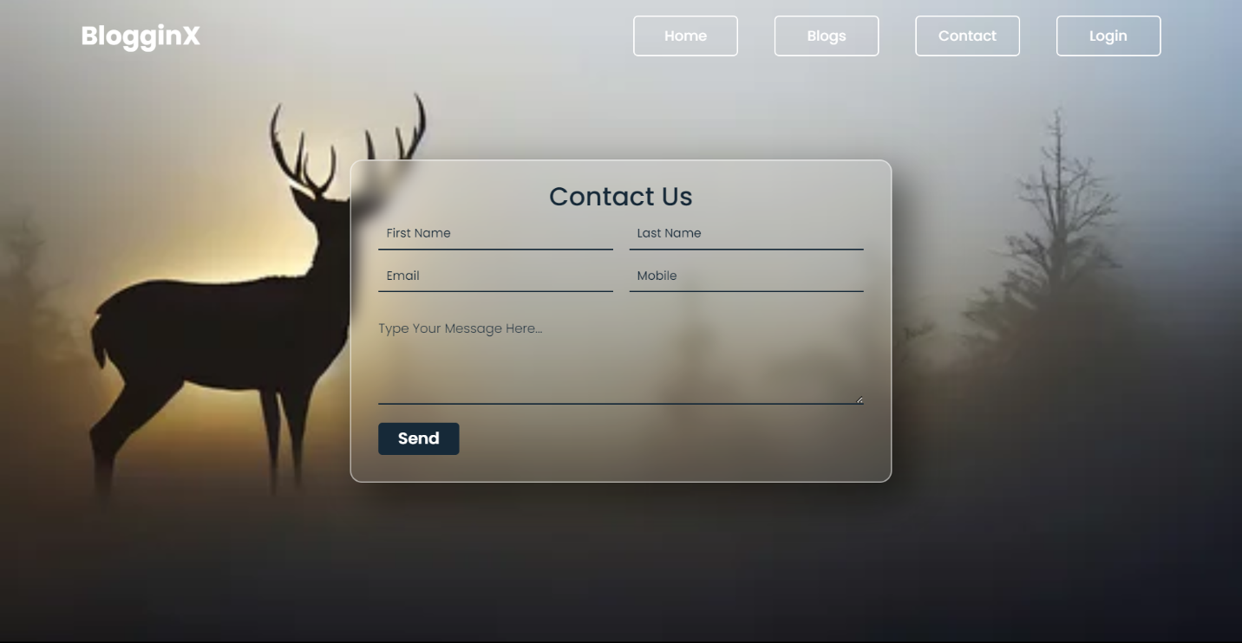

**Login page: -**

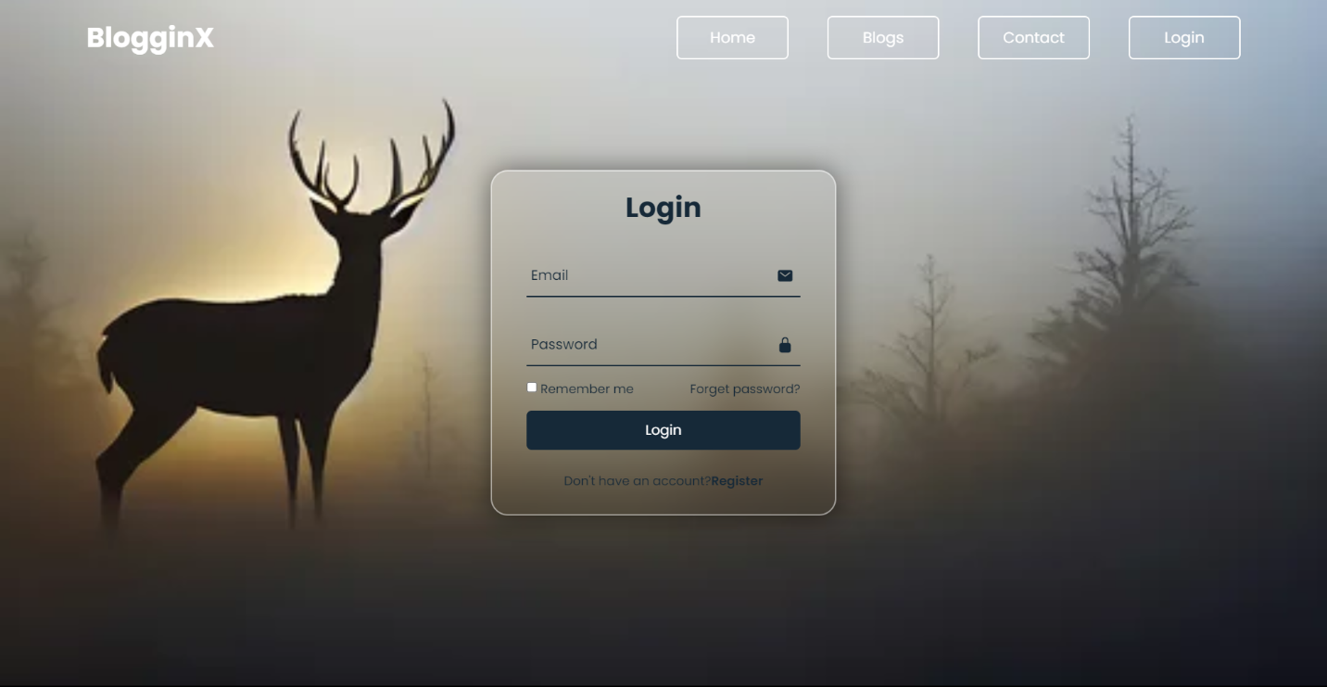

**Code Snippet: -**

**Home page –**

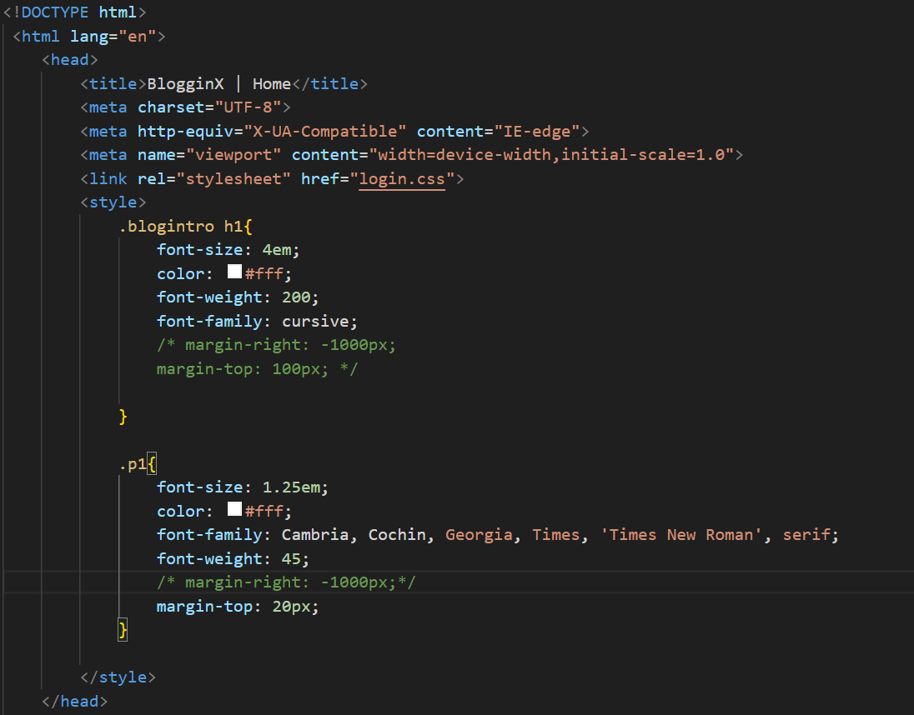

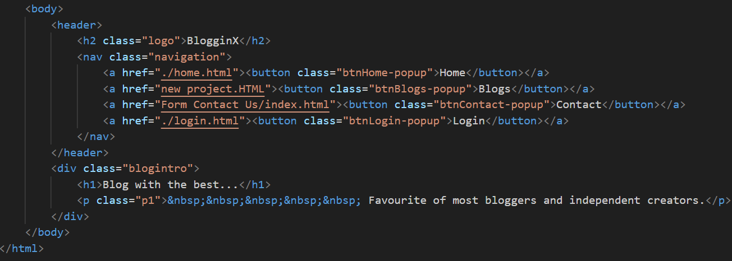

**Blog page –**

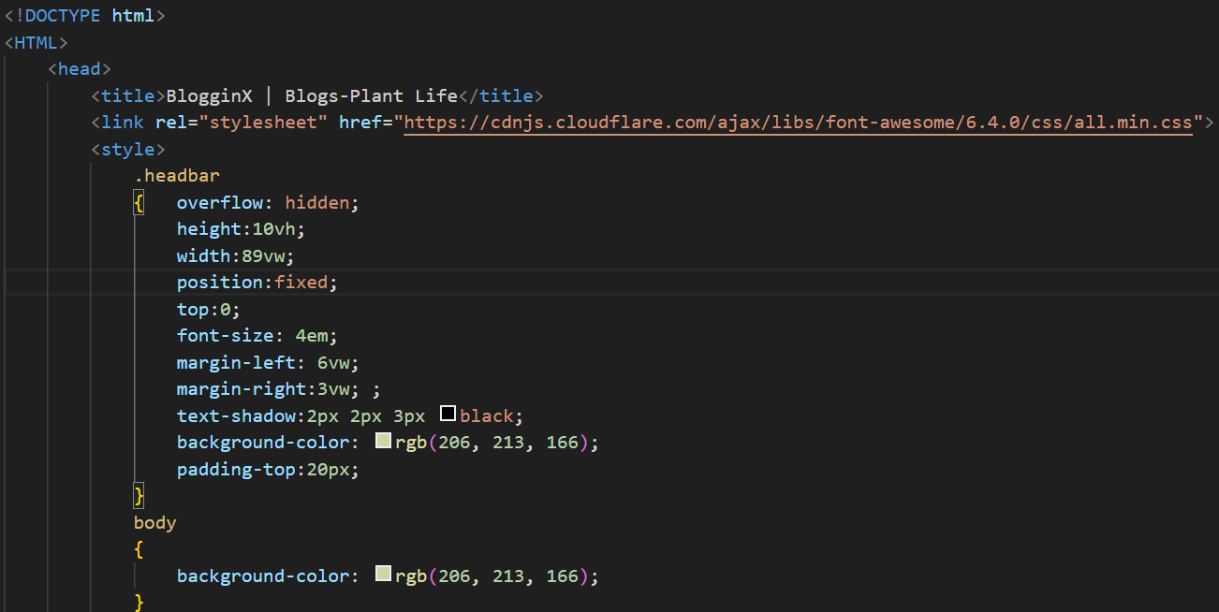

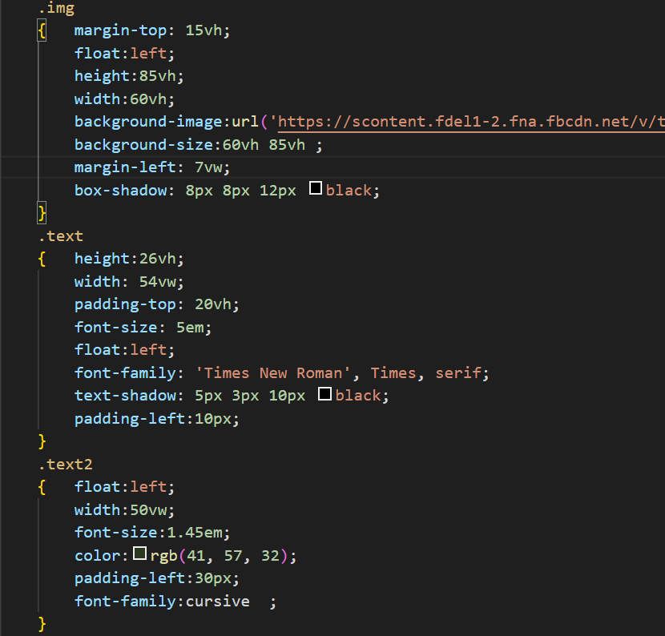

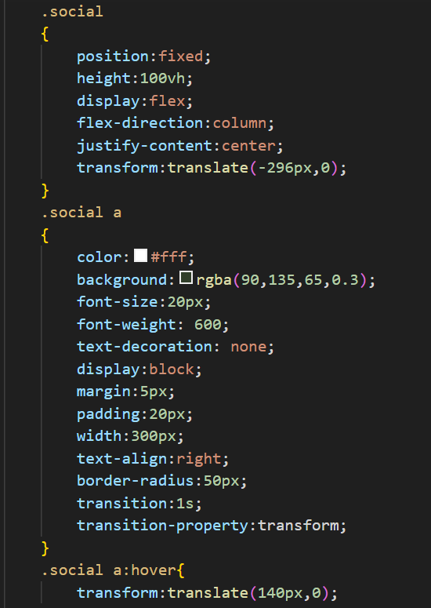

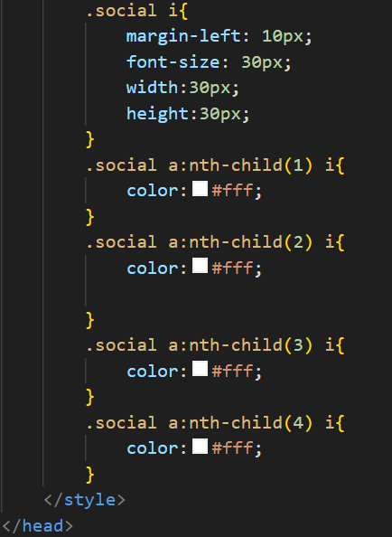

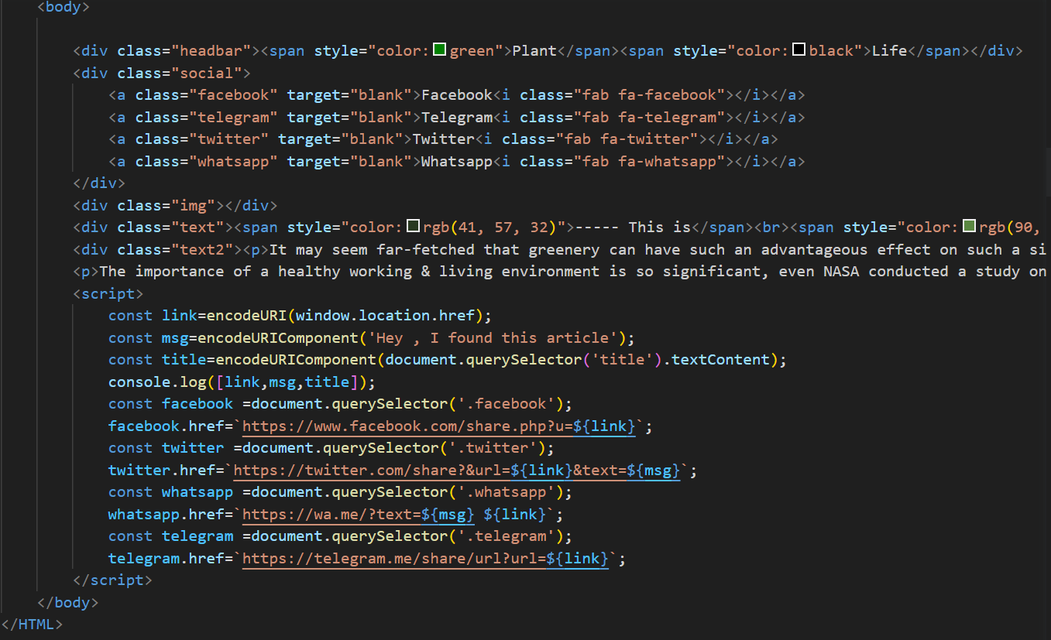

**Contact page –**

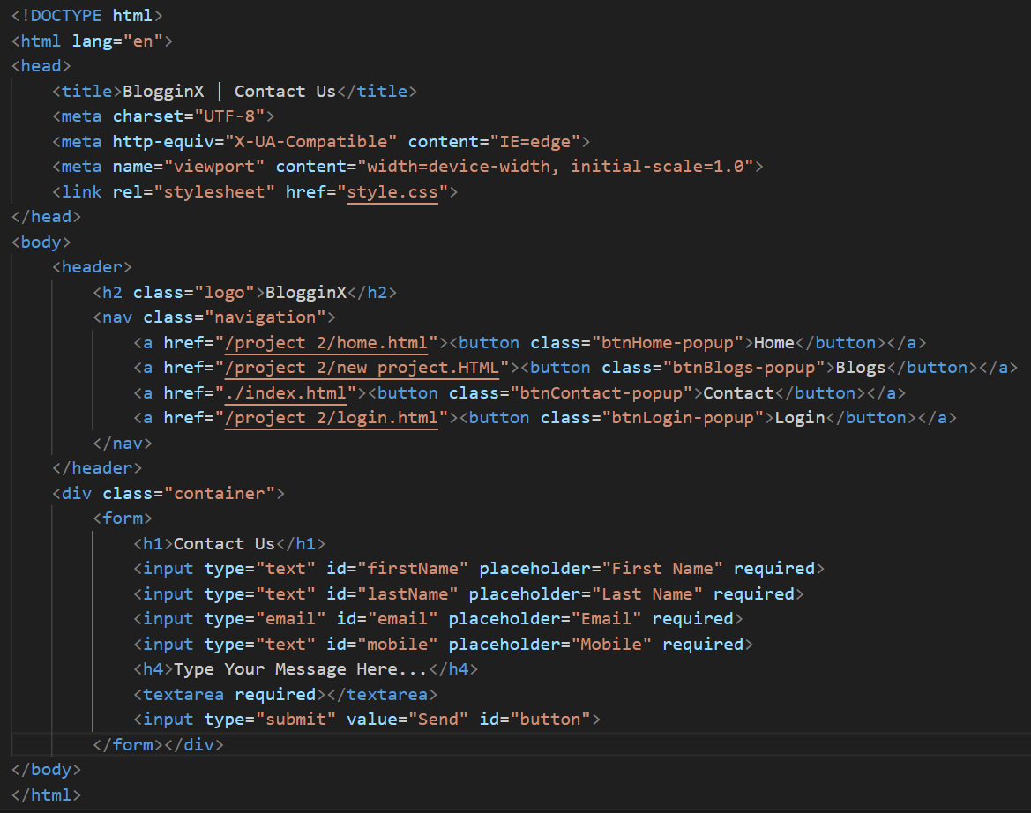

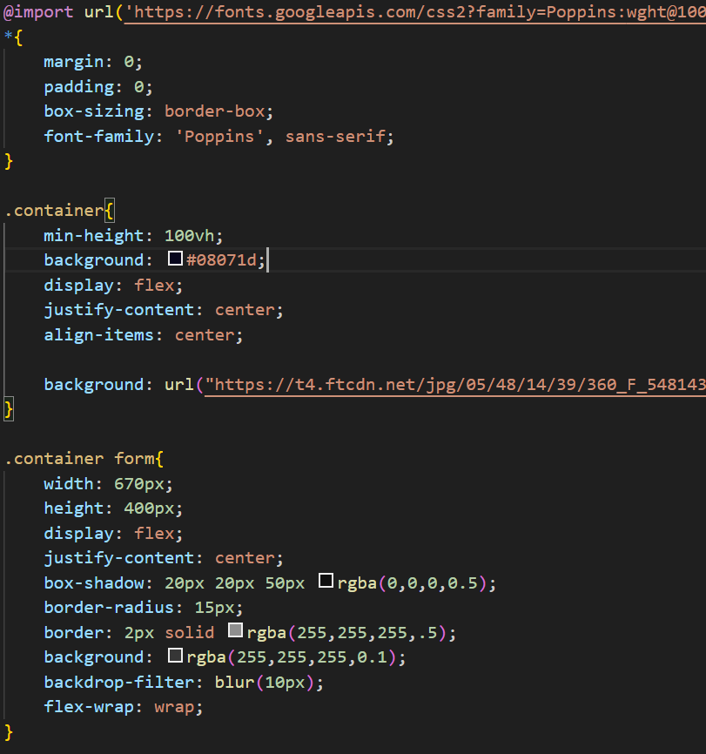

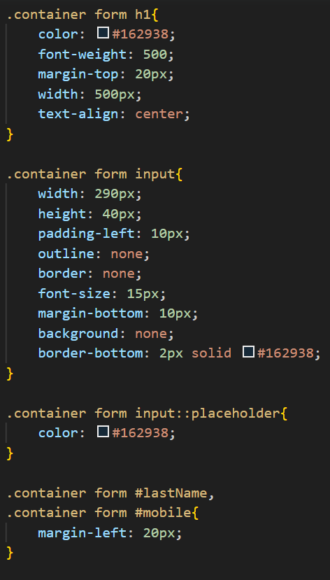

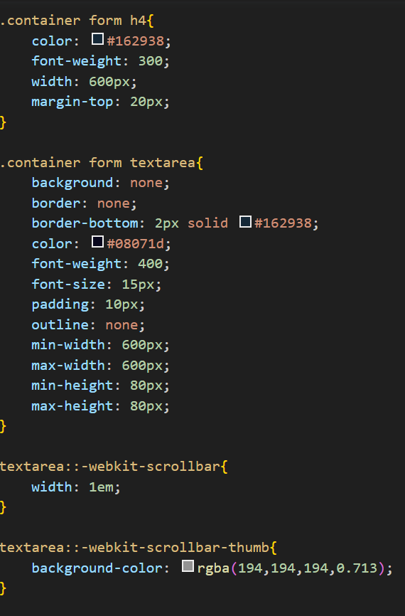

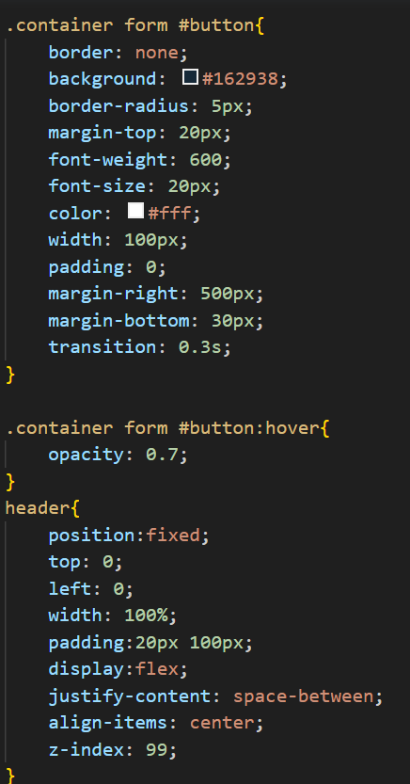

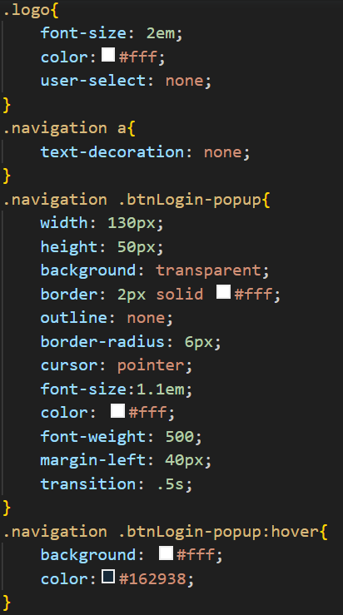

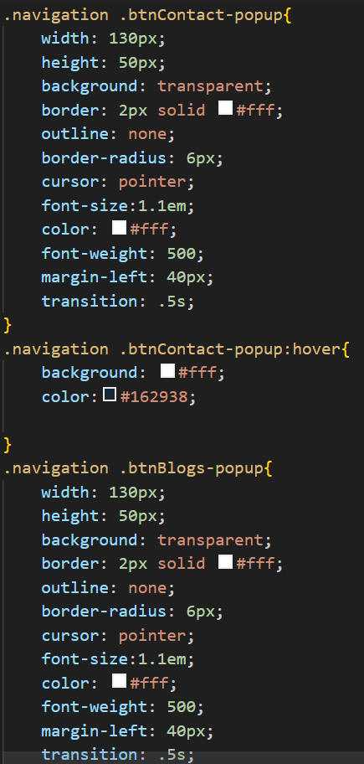

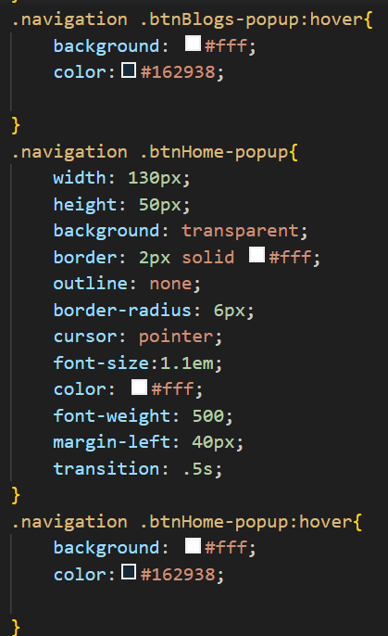

**Login page –**

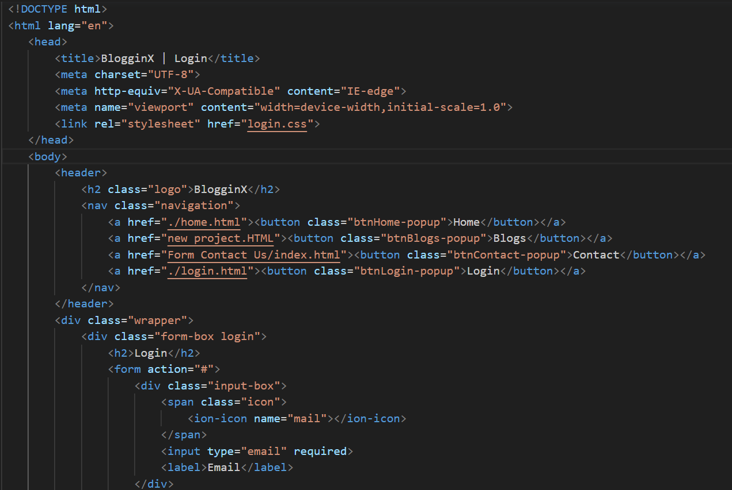

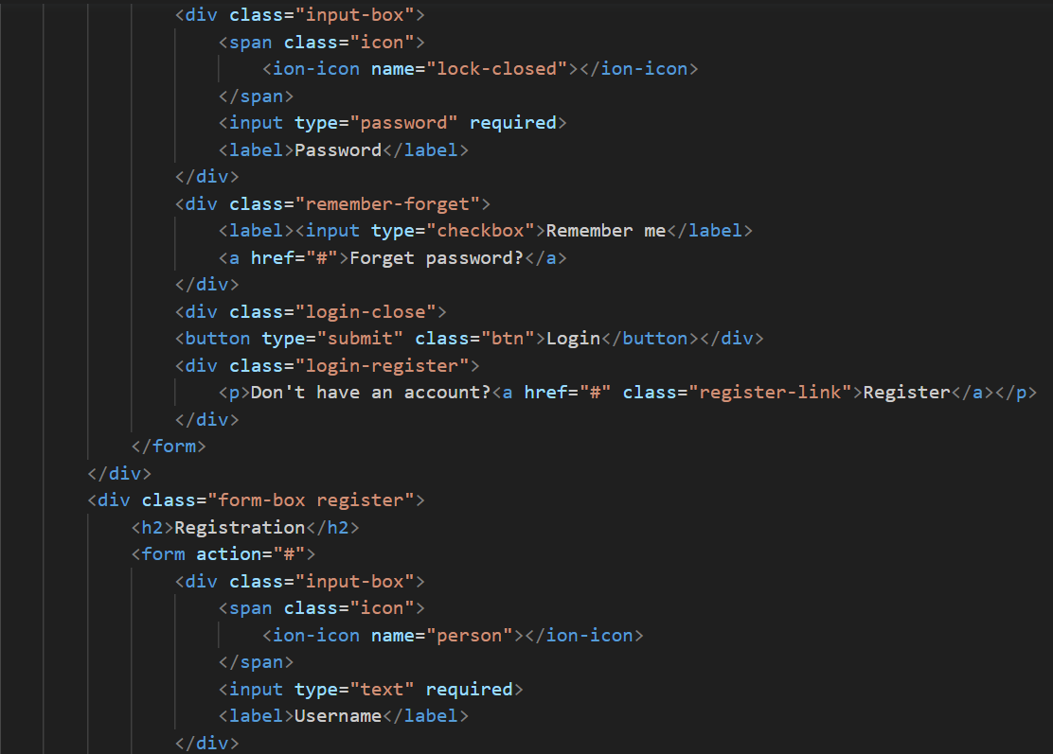

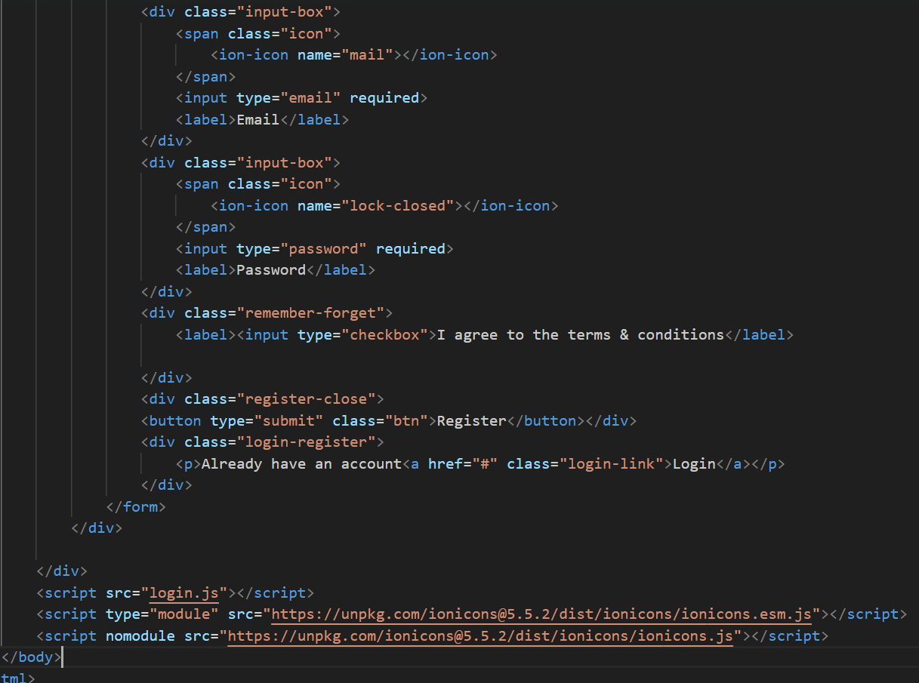

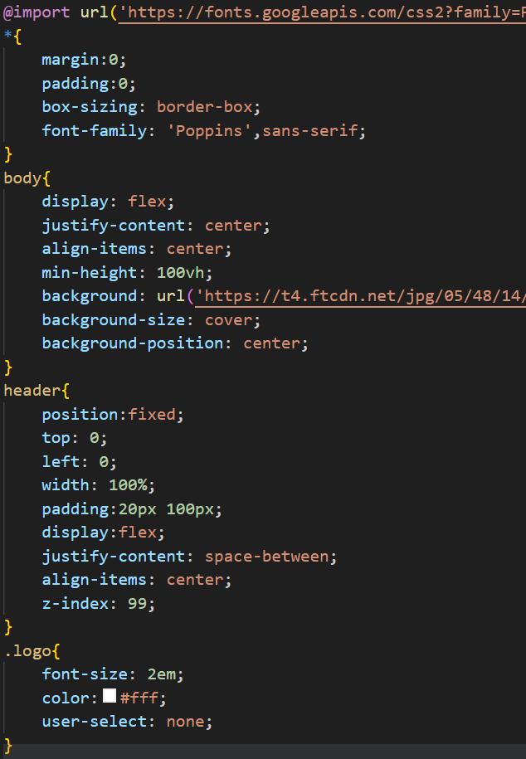

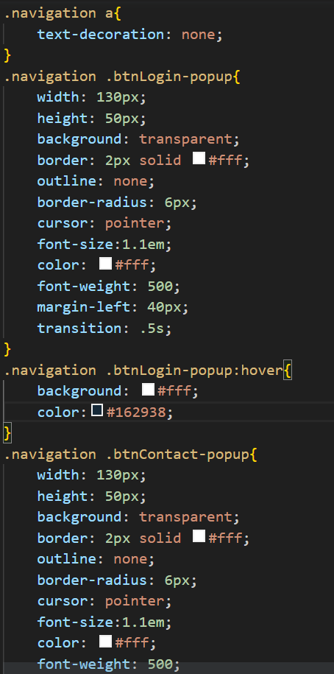

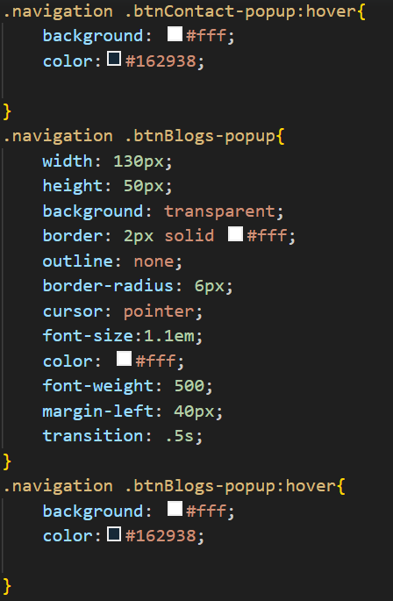

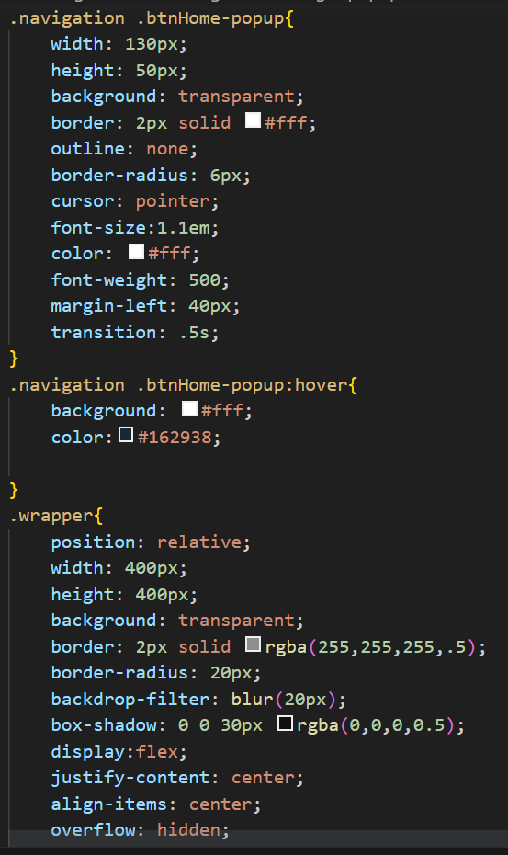

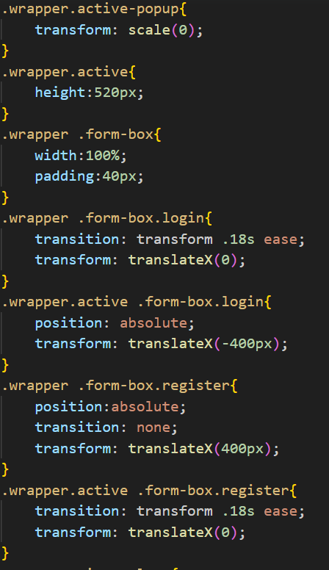

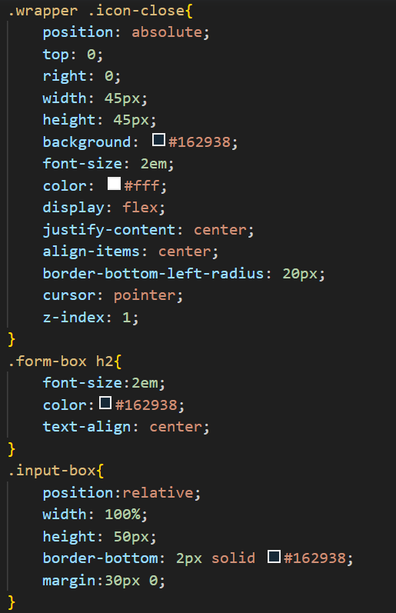

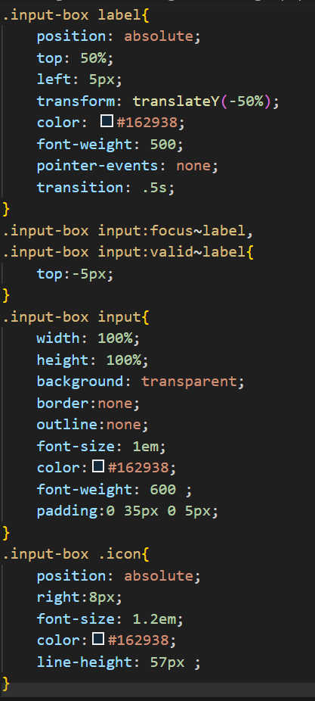



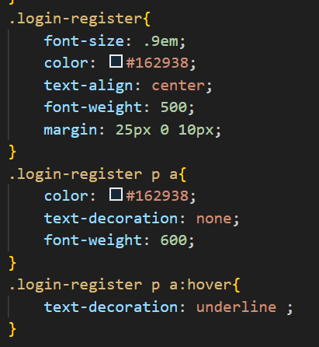

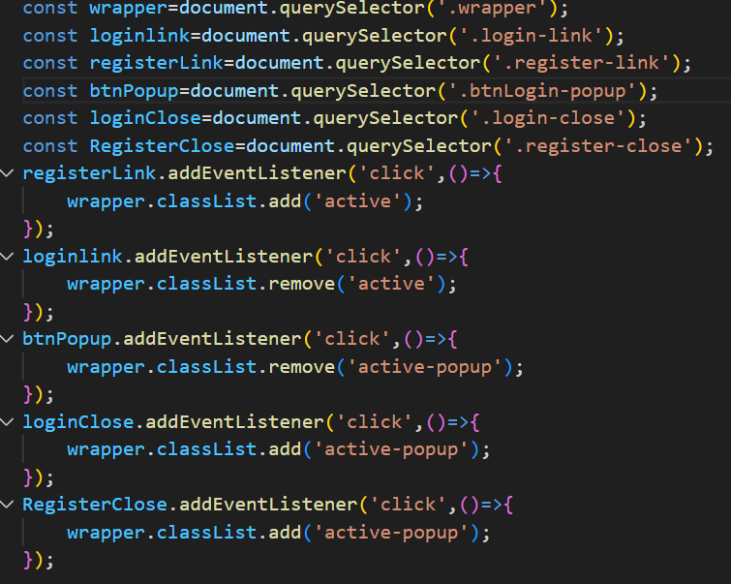

**CONCLUSION**

Social share buttons are a valuable tool for website and content creators to increase their social media presence and promote engagement with their audience. These buttons offer a range of features, including integration with social media platforms, ease of use, customization options, trackability, mobile-friendliness, and the ability to promote social engagement. By incorporating social share buttons into their digital content, website and content creators can increase their online visibility and reach a wider audience, ultimately helping them achieve their marketing and communication goals.

**FUTURE SCOPE**

The future scope of a project on social share buttons using HTML and CSS is promising, as social media continues to play a significant role in marketing and advertising. Here are some potential future developments for such a project:

1. **Integration with new social media platforms**: As new social media platforms emerge and gain popularity, there will be a need to integrate them into the social share buttons to keep up with user preferences and behaviors.

2. **Personalization and customization**: Users may want to customize the social share buttons to match their personal preferences or branding needs, which may require additional features to be added to the project.

3. **Optimization for different devices**: As technology continues to evolve, there will be a need to optimize the social share buttons for new devices and screen sizes, including wearables, smart TVs, and virtual or augmented reality devices.

4. **Advanced tracking and analytics**: Advanced tracking and analytics can help to monitor the effectiveness of the social share buttons and provide insights for further optimization.

5. **Integration with other tools and technologies**: There may be a need to integrate the social share buttons with other tools and technologies such as email marketing, analytics, or content management systems.

Overall, the future scope of a project on social share buttons using HTML and CSS is likely to involve ongoing improvements in design, functionality, and integration with other technologies to keep up with the changing social media landscape and user preferences.

**REFERENCES/LINKS USED**

* [**https://dribbble.com/shots/6211462-Daily-UI-010-Social-Share/attachments/6211462-Daily-UI-010-Social-Share?mode=media**](https://dribbble.com/shots/6211462-Daily-UI-010-Social-Share/attachments/6211462-Daily-UI-010-Social-Share?mode=media)
* [**https://youtu.be/7bVl8zyKr8g**](https://youtu.be/7bVl8zyKr8g)
* [**https://youtu.be/p1GmFCGuVjw**](https://youtu.be/p1GmFCGuVjw)